**Report Milestone 3**

Mainpage:

Top Left is empty space. Maybe we can use it!

**About page (maybe on the top left position)**

Carousel picture is too big

**Sell Button on the main page. Everytime visible**

Only one line. What the project is supposed to be.

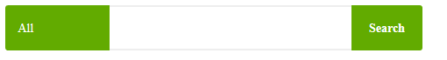

There should be a sign that All has a pulldown menu.

Step 1-4 (“How it works”). Quote: “Maybe let it or maybe not!” 🡪 Our choice but we should think about it.

Login / Register, Sell and Item button redesign.

Search:

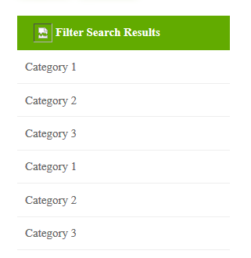

Category 1-3 should named as filter.

**If the search could not find the item with %Like 🡪 Show anything else + write a text “Unfortunately …”**

Itempage:

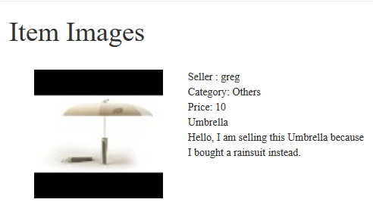

Item Images should be named as Item title

Registerpage:

Mark all fields as mandatory.

Message conversation is Priority B 🡪 Only one message to seller. There can we add a hint that the buyer should send his contact information.

**Category in Item should be solved with a foreign key!**

Posting Page:

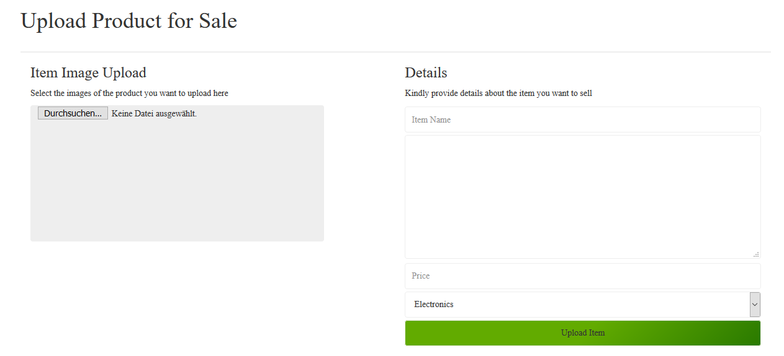

**Only one instead of two columns**

Github:

**Clear Github commits!**

**Good example: Change Dashboad Item Image added**

General Important:

**Add always header comments!**